Follow the instructions below to update your personal equality and diversity information through myportal.
If you don’t want to disclose a piece of information then please select non-disclosed.

Instruction | Visual
- Sign into my portal and the Employee Services Tab.
- Click on the Personal Information Icon. | 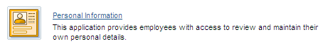
- Click on Ethnicity, Disability and Military Status (Additional Personal Data).
- Click the Edit icon. | 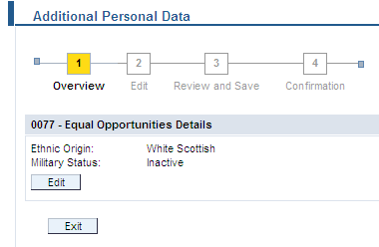
- Click on drop down box next to ethnicity and select your ethnicity. | 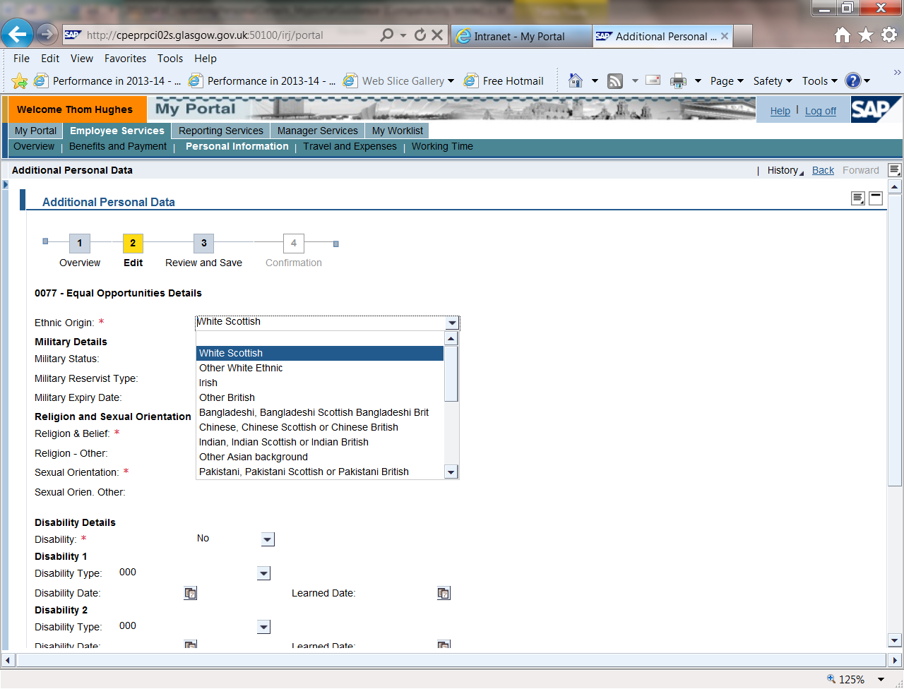
- Click on the drop down box next to religion & belief and select your religion or belief. If you select other please enter details in the box underneath the drop down box. | 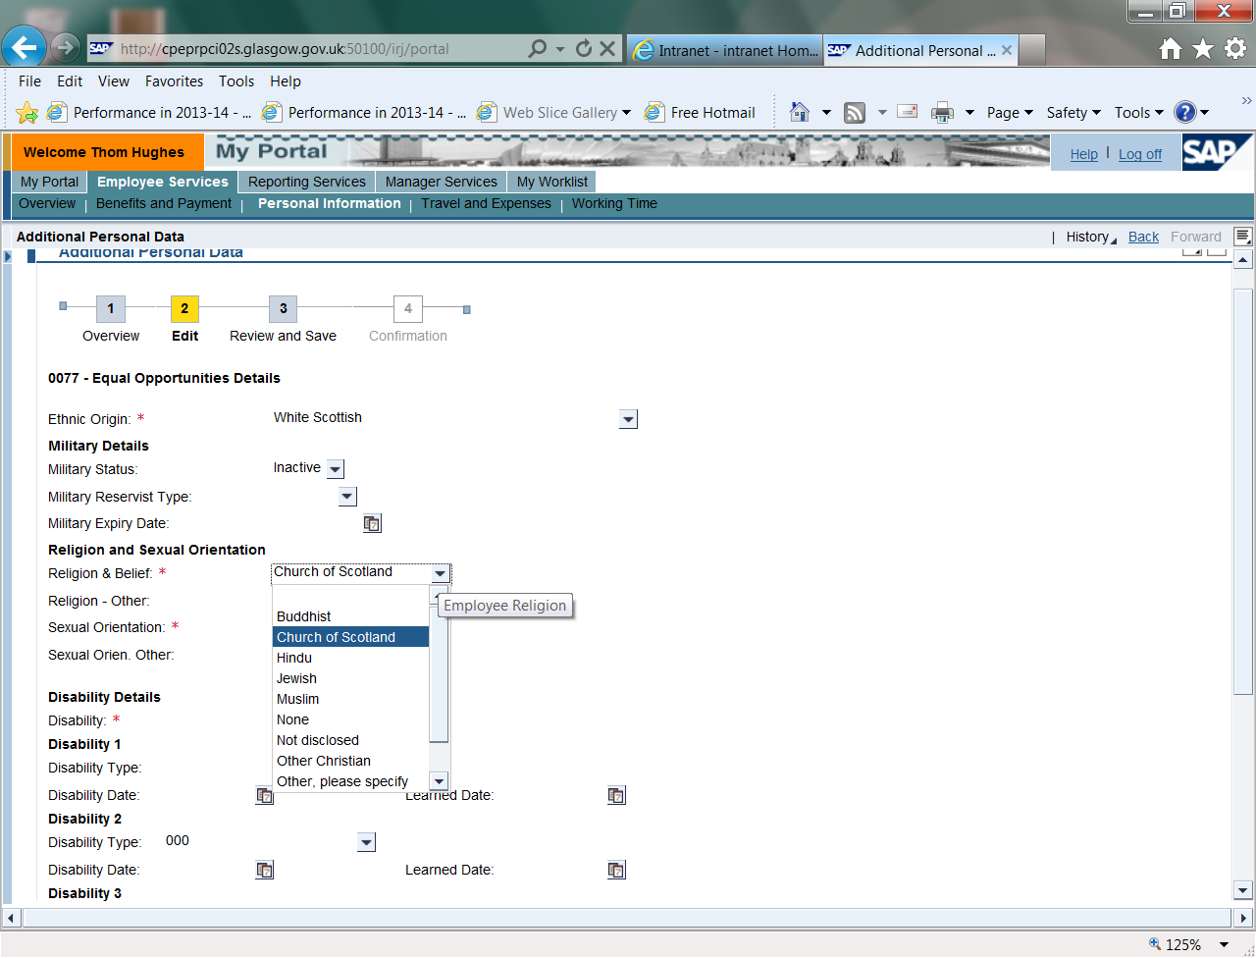
- Click on the drop down box at sexual orientation and select your sexual orientation. If you select other please enter details in the box underneath the drop down box. | 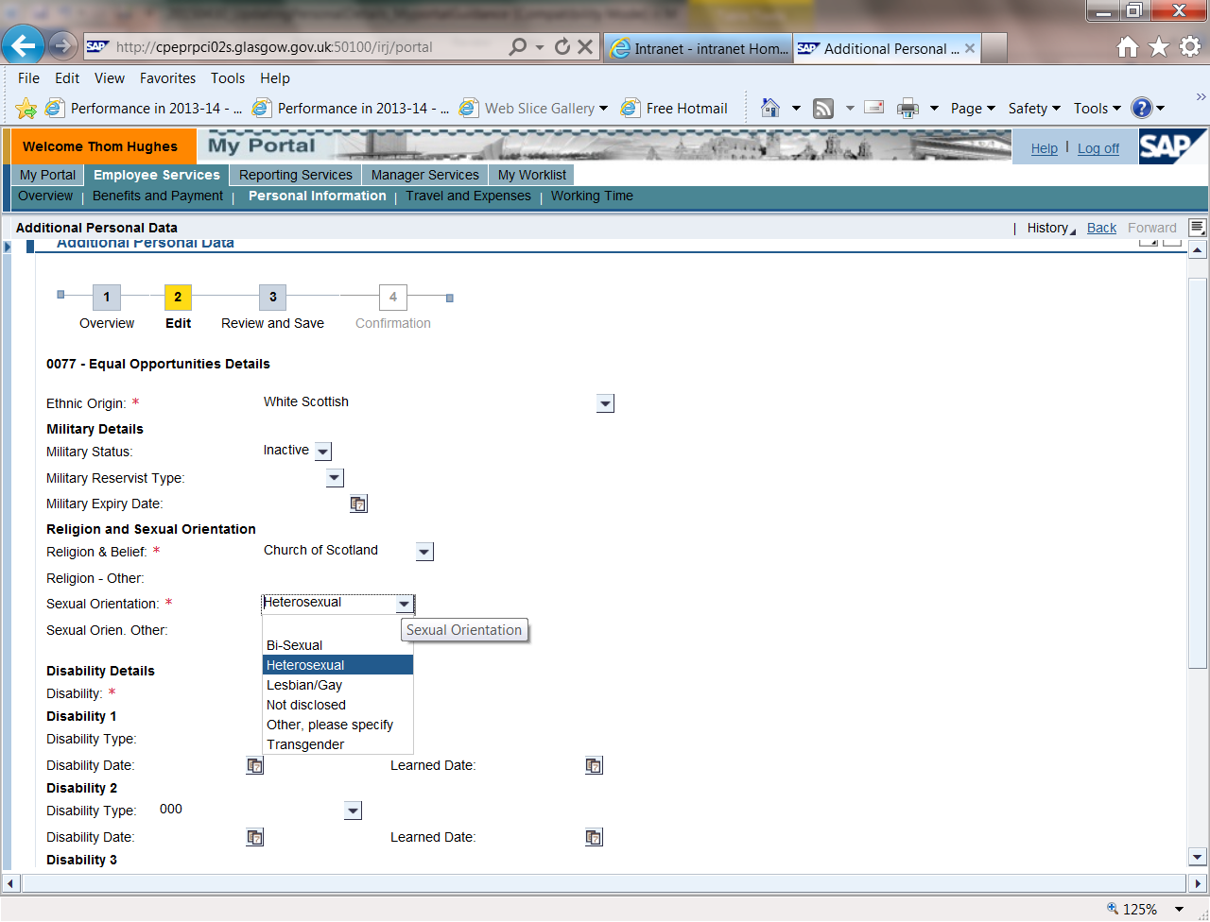
- Click on the drop down box next to disability and select yes if you have a disability or no if you don’t. | 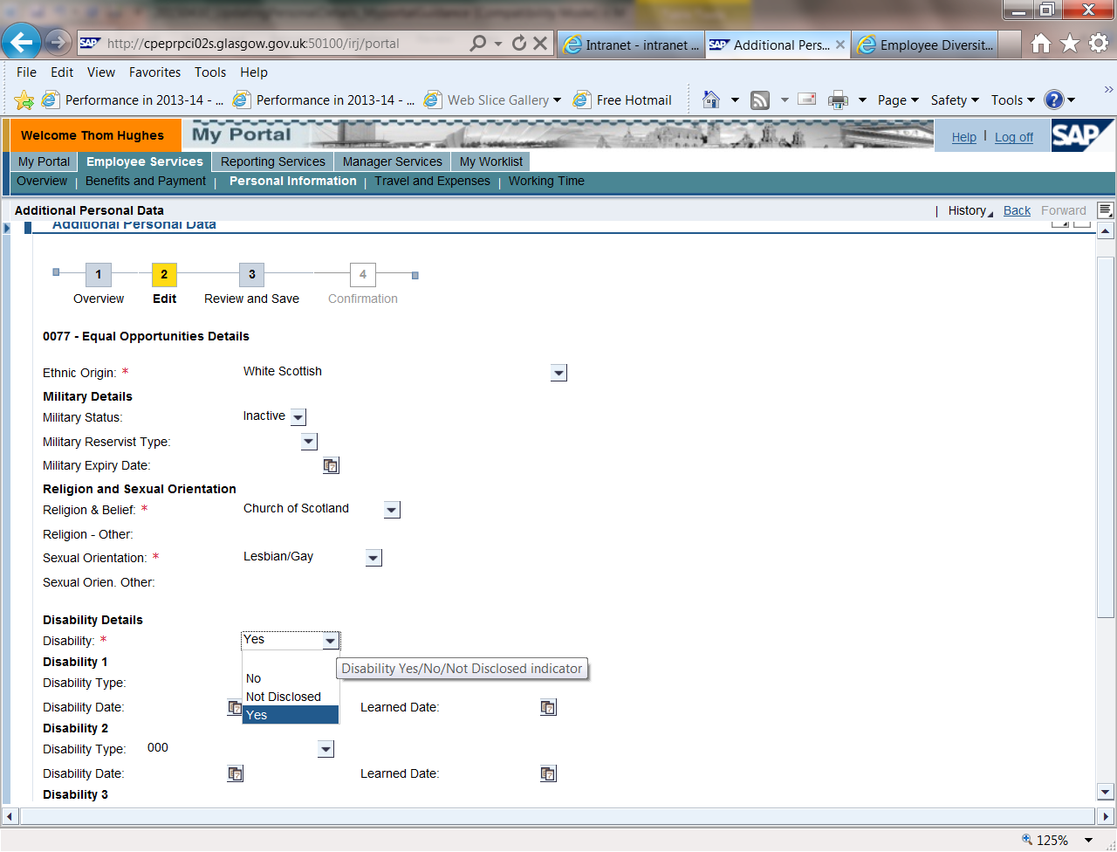
- If you selected yes for disability click on the drop down box next to Disability Type 1 and select the type of disability. | 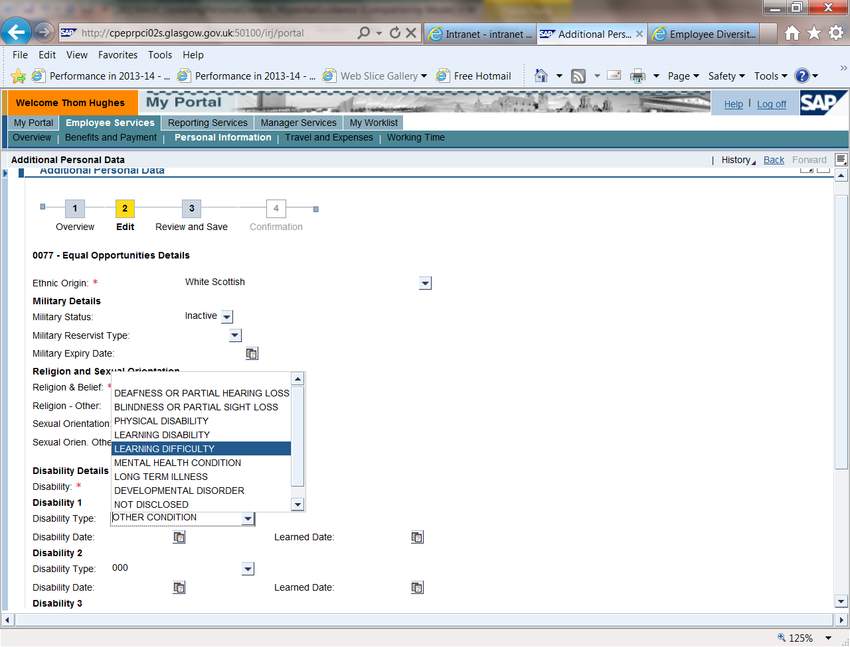
- Repeat steps 8 and 9 to disclose all disabilities.
- Click on review icon at bottom on the page. | 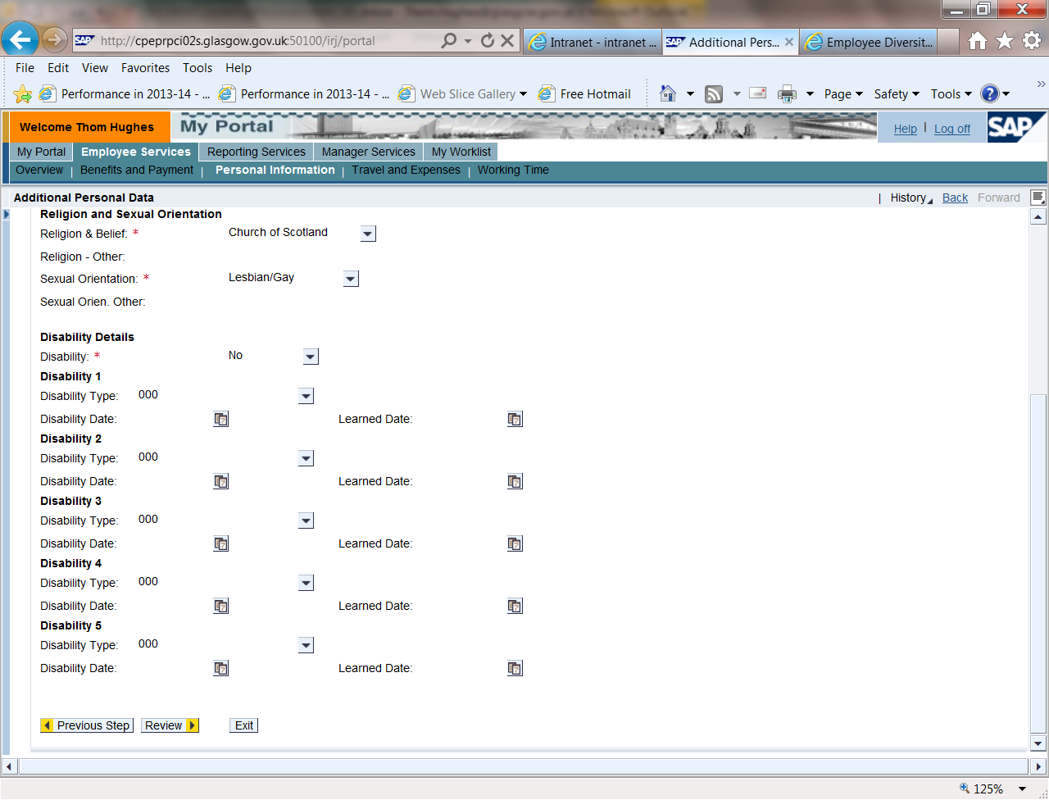
- Review your changes and click on save icon. | 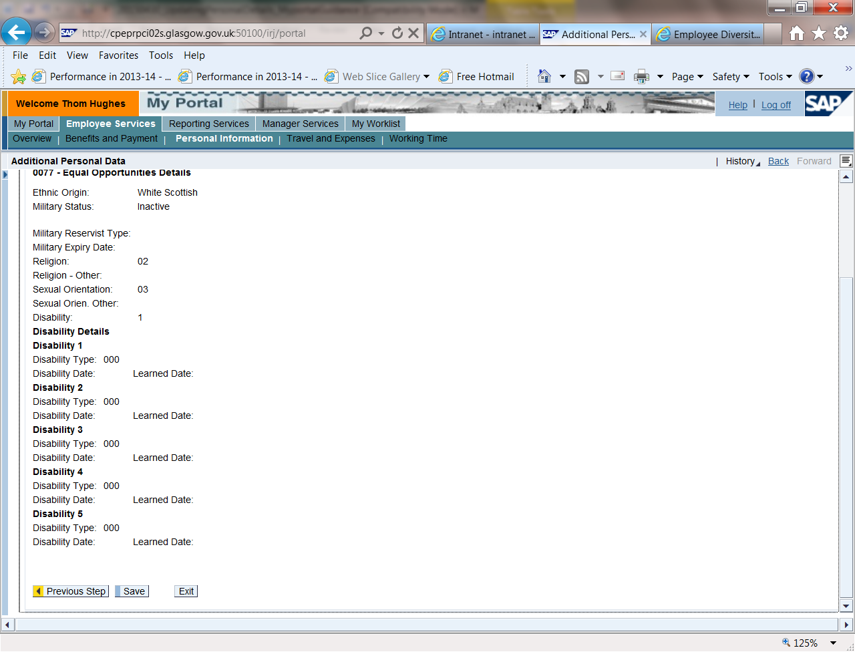
- Make sure you see the message – The changes you made to your Additional Personal Data were saved. | 