VISUAL ARTIST & CRAFT MAKER AWARDS: GLASGOW

2024-25 Bursaries

APPLICATION FORM

VACMA: GLASGOW is funded through a partnership between Glasgow Life and Creative Scotland

 | 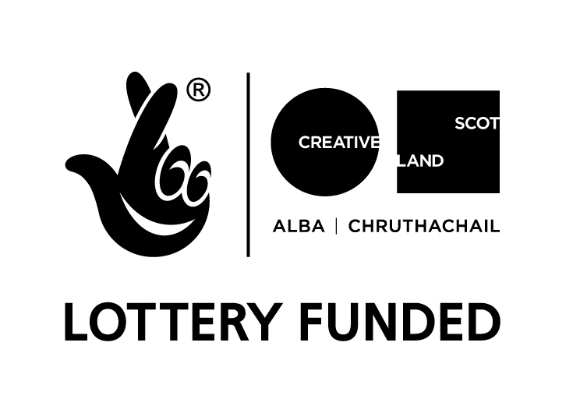 | 

Visual Artist and Craft Maker Awards: Glasgow
in partnership with Creative Scotland
#VACMAScotland

Please ensure that you have read the guidelines carefully before completing this form.

Your Details

Legal Name (for finance and contracting purposes)

Preferred Name (if different from your legal name)

Pronouns (optional)

Address

Postcode

Telephone number

Email

Website

Project start date
Project end date

I am applying for (Select one only) | ✓
Artist Bursary £1,000
Early-Career Bursary £500

Artform (Select one only) | ✓
Visual Art
Craft

Where are you based? (Please select all that apply) | ✓
I live in Glasgow
I maintain a studio in Glasgow

Project Summary

Please provide a short summary of your proposed activity. Please note that we may use this text for marketing and communications purposes if you are successful. (Max 30 words).

Your Proposal

Please tell us about your creative practice. Provide a brief outline of your interests and motivations, your creative process, the work that you make and any key achievements to date. (Max 250 words).

Please provide a description of your proposed activity. Tell us what do you want to do and why? You should expand on the information provided in the summary above. Try to be as specific as possible. (Max 300 words)

How will this contribute to your creative and professional development? How will the bursary support you to develop your creative skills and ideas? How might this impact on your practice now and into the future? (Max 300 words)

Please provide a brief timeline for your project and tell us about how you will manage any risks. Please outline the key stages of your project and tell us about any risks that you have identified and how you will mitigate them. If you have done any preparatory work, you can tell us about it here. You can use bullet points in this section. (Max 200 words)

Is there a public element to your proposal? If so, please tell us what it will involve and how you will reach or engage people? (Max 200 words)

Equalities, Inclusion and Diversity

Please tell us how you will consider Equalities, Diversity and Inclusion (EDI) within your proposed activity and/or wider practice. If you wish to make the panel aware of any barriers that have impacted upon your practice or proposed activity, you can tell us about them here. (Max 200 words)

Environmental Sustainability

Please tell us how you will minimise the environmental impact of your proposed activity and/or how you are responding to the causes and impact of climate change through your practice. (Max 200 words)

Previous Applications

Have you received a VACMA Award before? (Please tick)

Yes
No

Personal Access Costs

Do you require support with Personal Access Costs? (Please tick)

Yes
No

If yes, please provide a breakdown of these Personal Access Costs and tell us how much you need.

Budget

Does your project or activity cost more than the bursary you are applying for? (not including Personal Access Costs). (Please tick)

Yes
No

If yes, please fill in the budget table below and tell us where the other project income will come from.

Income
Source | Amount (£) | Cash or In Kind?
VACMA Bursary (£500 or £1,000) |  | Cash
Own contribution
Other sources of income (please detail)
Total Estimated Income

Examples of Work

Please enter details of the artwork submitted in support of your application. We request that all supporting material is clearly labelled with your name and the title of the work.

 | Title or description of artwork | Year it was made
1
2
3
4
5
6

Please note that we cannot accept hard copy material. All supporting material should be sent as electronic files. If sending images or videos, please be mindful of the size of files. You may wish to compile these in a single document such as a PDF or include weblinks.
Supporting Information - Checklist

Please make sure you include the following documents when you submit your application form.

A copy of your current artist CV  This helps us to understand what your experience to date. | Y/N
Letter of confirmation/support (optional)  If you are applying for the development of work for an exhibition or to participate in a residency, the panel will want to know what support the gallery or host organisation is providing. | Y/N
Examples of work  6 high quality images or up to 3 minutes of film/sound files. | Y/N
Equalities Monitoring Form  This form is anonymous, will be processed separately and has no bearing on your application. | Y/N

Use of Your Information

We are committed to protecting the rights and privacy of individuals in accordance with the Data Protection Act 2018. We need to process certain information about our staff, customers, and other individuals that we have dealings with for administrative purposes. We will also share the information provided with Creative Scotland as the funding partners to support evaluation, assessment and development. To comply with the Act, information collected about individuals must be used fairly, stored safely and securely and not disclosed to any third party unlawfully. Data Protection Act - The DPA 2018 sets out the framework for data protection law in the UK. It updates and replaces the Data Protection Act 1998, and came into effect on 25 May 2018. It sits alongside the GDPR, and tailors how the GDPR applies in the UK.

Privacy Notice
We are committed to protecting the rights and privacy of individuals in accordance with the Data Protection Act 2018. You can find out how we handle personal data at https://www.glasgowlife.org.uk/privacy/general-privacy-notice

How To Submit Your Application

Completed applications should be emailed to gl.learningteam@glasgowlife.org.uk

Applications should be submitted by email by the closing date. Along with your emailed application form six images of recent work should be attached, (no more than 4MB in total) .

When submitting your application, please ensure you send it as an email attachment rather than via a web hosting service. Please note, we are unable to accept documents in a Zip File. Applications must be emailed and not posted. There is no facility to hand deliver hard (paper) copies of applications. Please don’t send applications or artwork in the post.

There will be two funding rounds in 2024/2025, the closing dates are:

Autumn Deadline
Tuesday 22nd October 2024 @ 5.00pm

Winter Deadline
Tuesday 4th February 2025 @ 5.00pm

We are unable to accept late applications. Your application will be acknowledged within five working days. If you don’t receive an email confirming receipt of your application, you must contact us at gl.learningteam@glasgowlife.org.uk

Declaration

I (full name) _____________________________________ hereby apply for financial assistance towards the cost of undertaking the project described in this application. To the best of my knowledge and belief, the information given is correct.

Signature
Date

