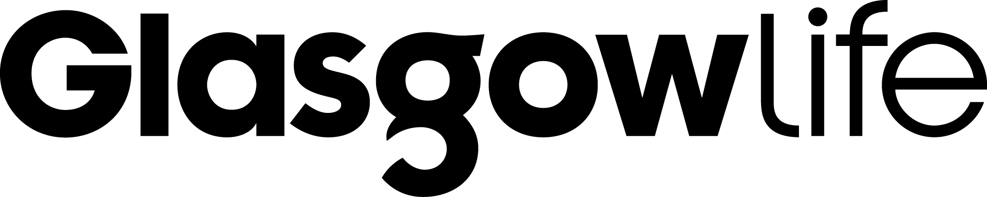 | Arts Development Scheme  Guidelines 2025/2026

Introduction

The Arts Development Scheme 2025/2026 aims to support arts and cultural organisations and local community groups with grants of up to £5,000 to help sustain Glasgow's cultural sector.

The scheme aims to support a range of inspiring cultural events and projects that help develop new ideas and improve ways of working, celebrating people and talent and bringing real improvements to local communities. Applicants should show how this funding will make a significant difference to their programme of work.

We will prioritise applications from those who identify in their application as disabled, BIPOC (black, indigenous and people of colour) and/or are organisations who are minority-led. We will also prioritise applications that are Gaelic arts, culture or language focused, to support the new Gaelic Arts and Music Strategy. If you would like to see a copy of the Gaelic Arts and Music Strategy, please contact the Gaelic Arts Officer Rona MacDonald Rona.MacDonald@glasgowlife.org.uk

Eligibility

Applicants must be a formally constituted group or organisation and have previously delivered arts activities in Glasgow. Applications will not be considered from previously successful applicants who have not submitted their Final Grant Report Form. Larger organisations with an annual turnover more than £150,000 are unlikely to be supported from this scheme.

We are unable to consider applications from individuals or newly established organisations or organisations in receipt of funding from Glasgow City Council.

Applicants should:
- have a Managing Body, management committee (or similar body) which meets regularly;
- have elected office bearers e.g. chairperson, secretary and treasurer or equivalent;
- have a Governing Document or equivalent (e.g. a constitution) that has been approved by the Organisation and signed by an office bearer

The following are not eligible for support from this scheme: Start-up costs for new organisations or funding for capital projects, Building Development and Travel Costs. We cannot consider applications to run, enter or apply for Competitions, Scholarship or Bursary Schemes.

If your project takes place in a Glasgow Life venue (Tramway, GoMA and City Halls etc) the nature of any support, including in-kind, should be itemised and included in your budget. Projects that receive support from Glasgow Life Festivals (MCF, Mela, Celtic Connections, Aye Write, Glasgow International, Dance International Glasgow) are not eligible for support from this scheme. However, projects that are re-staged as part of these festivals may be considered.

Project Timescale

This scheme is to support arts activities delivered in Glasgow between September 2025 and March 2026. Activity must be time-limited and for a specific purpose.

Finance

Applicants must have a current bank account in the name of the organisation or group. Glasgow Life will not make grant payments to individuals even if they are officials of the organisation. Awards are not given retrospectively. We do not fund activities that have already started, or that start before a decision has been made on your application. All applicants must demonstrate a broad funding base, we are unable to fund the total cost of a project.

Applicants should have financial procedures in place explaining how money is managed. As a minimum, we expect you to have a set of written procedures, agreed by your management committee which sets out arrangements for:
- cash expenditure and cash handling
- cheque signing and authorising withdrawals (including the use of debit/credit cards)
- invoice authorisation and financial record keeping

If successful, you might not receive the full amount applied for and the assessment panel reserves the right to offer a different amount to that requested.

Successful applicants must not start work, incur costs, or place any orders before any grant offer has been issued and accepted. You must not issue or enter into any contracts before the date of the award letter. You must not refer to our support in publicity material before you have received our offer letter and met any conditions that may be included in it.

Project Outcomes

The primary consideration when assessing applications will be how they align and contribute to the Arts Development Scheme Project Outcomes and will focus on activities that help create and sustain a successful, vibrant city. We are looking for projects that:

- Deliver high quality targeted arts & cultural activity | - Innovate within & between artforms
- Are economically resilient. | - Improve equality & social cohesion
- Encourage participation & active citizenship | - Improve the local environment

Access and Participation

Applicants must be able to demonstrate that they have an open access/equal opportunities approach towards membership and participation, use of facilities and activities. Applicants are required to take reasonable steps to ensure their activities can be made available for as broad a range of people as possible and that positive measures are put in place to remove any barriers to access. The aim of the fund is to support work that builds engagement with culture in areas where there is little provision and to enable the broadest possible participation in the arts.

How to Apply

Completed applications should be emailed to gl.learningteam@glasgowlife.org.uk the subject title of your email should be Arts Development Application. Incomplete applications will not be considered. Applications should be submitted by email by the closing date and not posted. Please note there is no facility to hand deliver hard (paper) copies of applications. Keep copies of your application and supporting documents. When submitting your application, please ensure you send it as an email attachment rather than via a web hosting service (Google.docs, iCloud etc). Please note, we are unable to accept documents in a Zip File.

Closing Date

The closing date is Friday 25th July 2025. We are unable to accept late applications. If you submit your application after the closing date it will not be considered. Your application will be acknowledged within five working days, if you don’t receive an email acknowledging receipt of your application you must email gl.learningteam@glasgowlife.org.uk

Privacy Notice

The Glasgow Life Privacy Notice forms part of these guidelines and relates to the information you provide in your application and how Glasgow Life process it. The application form asks for personal details about you, individuals within your organisation and people working on the project. By signing the application form you are confirming that you have the authority to provide these details on behalf the named individuals. You should read this notice before submitting your application.

General

If you have any general enquiries, please email gl.learningteam@glasgowlife.org.uk and a member of the team will contact you.

